Sphera, from Forbo Flooring Systems, has been born out of a brand new, state-of-the-art production facility, utilising all the latest insights and technology to set a new standard in homogeneous vinyl flooring. With a unique in-house chip making process and the use of innovative new colour pigment spheres, Sphera Element offers the freshest, cleanest colour palette available on the market, with a harmonious range of contemporary tones.

Heralding a step change in how homogeneous vinyl is manufactured, Forbo’s new internal extrusion process enables the creation of multiple chip sizes and shapes depending on the design effect desired. What’s more, the new production techniques and processes means that Sphera achieves best in class dimensional stability, which helps to ensure the long term appearance and performance of the floor covering.

Manufactured and designed in Europe to reflect today’s most relevant colour trends, Sphera Element’s sophisticated palette consists of 62 shades, from warm and cool neutrals to complement wood and stone, to calming pastels and bolder more saturated hues for way-finding, zoning and accent colours. The new homogeneous range is also truly non-directional, an added benefit for contractors.

The range also benefits from SMART (Sustainable Modern Advanced Robust Technology) technology, with the SMART-top finish ensuring Sphera has a high resistance to chemicals, scratches and stains. While the in-line coating and subsequent embossing process results in superior appearance and durability, which sees the new Sphera range achieving the highest abrasion wear rating group T.

Sphera flooring adds character and style to floors across numerous applications. Whether in demanding, hygienic healthcare environments, in flexible, multi-purpose modern public buildings or in education facilities and offices where durability and colour are key.

Julie Dempster, Marketing Manager at Forbo Flooring Systems, said: “At Forbo we are committed to manufacturing floor coverings that contribute to a healthier indoor environment and our new Sphera Element range is no different; it has low emissions and is 100% phthalate free.

“What’s more, as light affects almost all vital processes in the human body and impacts people’s performance, health, safety and sense of well-being, we have ensured that almost half of the colours within the Sphera Element range have a Light Reflectance Value (LRV) higher than 40%, in order to maximise any form of lighting within a building – whether that it is natural or artificial lighting.

“Sphera Element also co-ordinates well with other Forbo floor coverings, including our Allergy UK approved Marmoleum and other Tessera and Flotex textile solutions offering end users and contractors a one stop shop service.”

For more information please visit www.forbo-flooring.co.uk/sphera

-ENDS-

Image | Information
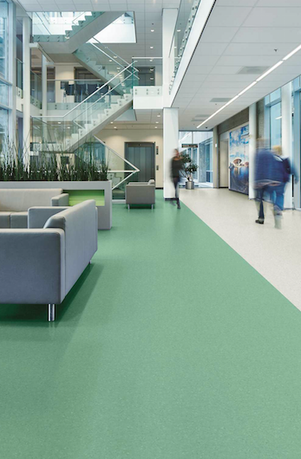 | Sphera Element in Jade 50045
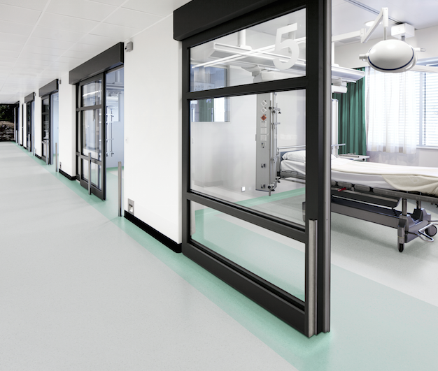 | Sphera Element in Silver Grey 50008 and Turquoise 50044
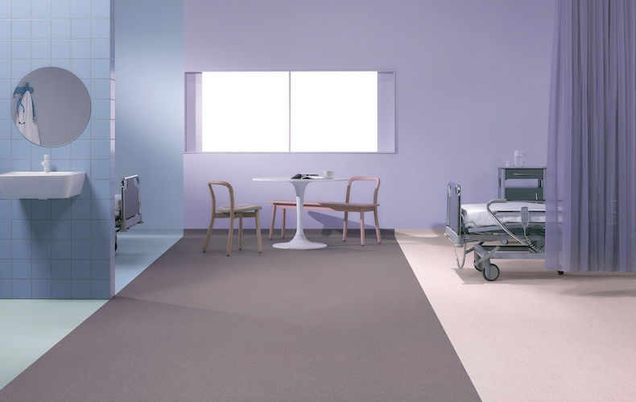 | Sphera Element in Soft Lilac 50032, Dimgray 50033 and China Blue 50037
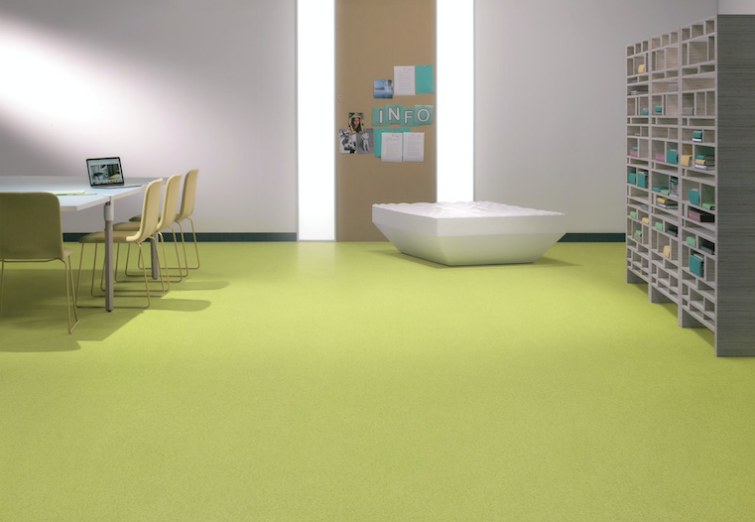 | Sphera Element in Yellow Green 50049

Tested to EN660-2
http://www.zumtobel.com/PDB/teaser/en/AWB_Buero.pdf

