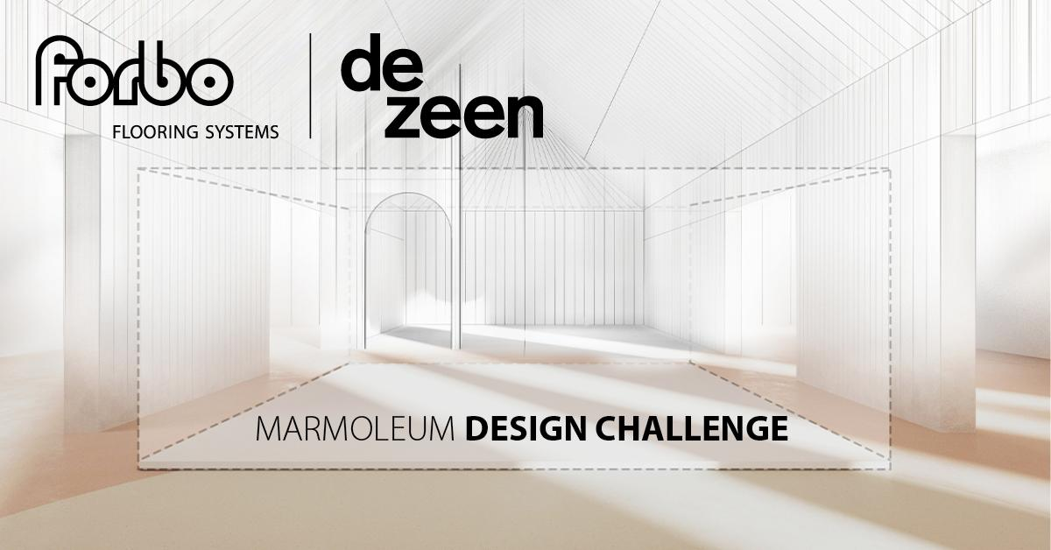

Forbo Flooring and Dezeen launch Marmoleum Design Challenge

Dezeen magazine has teamed up with Forbo Flooring to challenge architects and designers to create an interior space that promotes wellbeing using Forbo Flooring's Marmoleum material.

The Marmoleum Design Challenge tasks entrants with creating a small space within a space that can provide respite and enhance wellbeing in environments such as schools, offices or hospitals – anywhere where you can play, learn, work or heal.

The competition is free to enter for anyone over the age of 18 working in or studying architecture or design, from any country around the world. The challenge is open for entries until 30 April 2024. A shortlist of the best ideas will be published on Dezeen in May with the final result announced in June.

The winner will receive a £5,000 cash prize as well as having their design realised in collaboration with Forbo Flooring and exhibited in the brand's showroom in the Netherlands. The winner will also be invited to attend the launch event in the Netherlands.

Entrants challenged to make use of Forbo Flooring's Marmoleum material
Entrants are tasked with designing a 10-square-metre space that can enhance wellbeing by providing a space for relaxation and rejuvenation. Entrants must use Marmoleum as flooring and the design should be realistic and feasible to construct.

Marmoleum is a linoleum flooring product by Forbo Flooring that is crafted from natural raw materials, including linseed oil extracted from flax plant seeds, wood flour, limestone, pine resin and jute plant fibres.

As a result, it is climate-positive from cradle to gate, without offsetting. This means that the carbon dioxide absorbed by the biobased materials used to make the product is greater than the carbon dioxide emitted by manufacturing it.

Entries to be judged by Ilse Crawford among other leading designers
Competition entries will be judged by an expert panel comprising Dezeen editors and design professionals, including interior designer Ilse Crawford, HOK senior interior designer Christine Vandover, one of the co-founders of Studiopepe, Forbo Flooring’s senior designer for Marmoleum Tamar Gaylord and Dezeen editorial director Max Fraser.

Judges will be looking for innovative but buildable ideas for a wellbeing space. Entries will be judged against the following criteria:

- Strength of the overall idea
- Aesthetics
- Functionality and practicality
- Originality
- Positive impact on the user's wellbeing
- Use of Marmoleum
- Positive environmental impact
For more information about how to enter, including the full brief and rules, visit www.forbo-flooring.co.uk/marmoleumchallenge

Should you have questions about the challenge, please sent them to forbo@dezeen.com

