From chic metallic and bright sparkle designs to sophisticated natural wood and stone effects, Forbo Flooring Systems inspires designers with a far reaching range of designs as part of its new look Eternal general purpose vinyl collection.
Colour and pattern are staggeringly influential in transforming a space, affecting the mood and atmosphere intrinsically. Forbo’s new offering to specifiers - across all segments - certainly reflects this by capturing a very fresh, vibrant look and feel, whilst retaining all the practical performing elements that have always made Eternal a hugely popular flooring choice.
Forbo’s sheet general purpose vinyl has always been the benchmark in hetrogeneous design, however the PUR+ finish and advances in digital representations elevate the new Eternal offering to an altogether different level. A considered expression of patterns and finishes have been combined in a ‘hybrid’ approach to add character and depth to the ranges.
One of the key elements to the new Eternal collection is the digital print section, where there really are no limits to what can be created. With exceptional colour clarity and print capabilities, the impressive geode designs beautifully depict the cross section view of a crystalline rock in dramatic detail, whilst the spectacular Rainbow design’s intense hues emit a warm and vibrant mood. So for truly stand out features, to the more unusual pictures and patterns, the digital capabilities afforded by Forbo are staggering and worth exploring to see what can be achieved.
Leading in design performance, Eternal’s brand new gradient designs are a unique example of impact and intrigue. With expert colour and shade graduation, these fresh designs will add depth and interest to any application area. Complementing these, Forbo’s new Sparkle collection coordinates with four of the gradients to add an entirely new distinctive style. By using particles as opposed to chips, a more subtle and compelling effect is created against the solid colour backgrounds, ideal for the education sector where bright colours and stimulation are required.
The collection sees a new and improved colour palette, along with the introduction of stunning new effects such as painted, patched and striped in the wood range that will appeal to recent fashions and trends. In fact, the wood options have been carefully selected so that they offer a variety of natural finishes; pine, oak, beech, walnut all within a deliberate design approach that remains true to the natural product. The credibility is in the authenticity and the plank widths and lengths available reflect what you would see in a real wood floor – in fact the 150cm pattern repeat is the longest in the market. Meanwhile colour fastness and a unique PUR Wood Pearl embossing on selected designs, help to provide wholly realistic wood structures that do not compromise on the cleaning and maintenance.
With strong environmental credentials; 50% recycled content within the backing and
installation wastage fed through the recycling scheme ‘Back To The Floor’, the
production of Eternal carries on the Forbo ethos of striving to create better environments
in the manufacturing process of all its products.

Julie Dempster Marketing Manager at Forbo Flooring Systems comments: “Our in-house design team have excelled in producing an altogether unique identity with the digital and gradient designs, whilst offering a contemporary twist on the natural effects. Meanwhile Eternal's high tech PVC wear layer and PUR Pearl finish are key to the collection's ability to keep its as-new appearance even after years of intensive use.”
For more information on Forbo Flooring System’s Eternal general purpose vinyl collection please visit www.forbo-flooring.co.uk/eternal
-ENDS-

Image | Caption
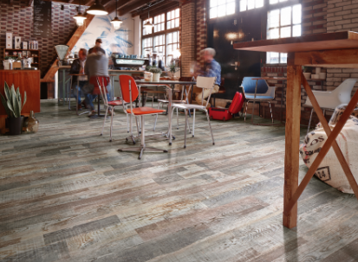 | Eternal 10982 original patchwood
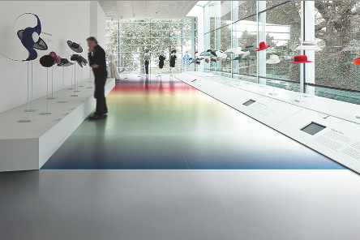 | Eternal 44752 rainbow
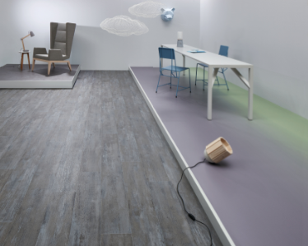 | Eternal 44852 violet-mint gradient and 13122 grey painted wood
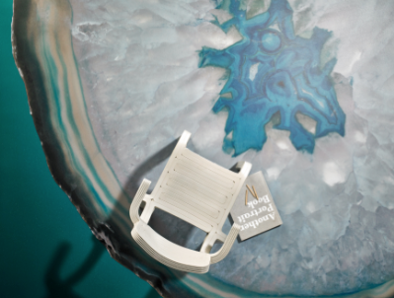 | Eternal 44912 colourful geode

