N10 GENERAL FIXINGS/FURNISHING/EQUIPMENT
300 ENTRANCE MATTING

A range of entrance flooring systems for internal and external applications. The double sided construction allows the product to be reversed and interchanged to optimise performance and wear. Available in open and closed construction and 12mm or 17mm thickness.
Tuftiguard Standard Duty Classic – comprising buffed grey wiper strips and anodised aluminium, bamboo or black anodised aluminium. For internal use only.
The modules can be fitted into existing or purpose built matwells or can be surface mounted using a purpose made ramp frame.
Consult with Forbo Flooring UK Ltd for technical details and to obtain samples.
Manufacturer: Forbo Flooring UK Ltd, P O Box 1, Kirkcaldy Fife, KY1 2SB.
Tel: 01773 740 688 Fax: 01773 740 640
Email: info.flooring.uk@forbo.com. Web: www.forbo-flooring.co.uk

Reference: Tuftiguard Classic

Construction: Open/closed [Select required option]

Wiper Colour: GY grey

Wiper Config: Single wiper recommended for areas over 3m in depth. / Double Wiper recommended for areas less than 3m in depth.
[Select required option]

Scraper Bars:* Select required option from:
Anodised aluminium
Bamboo
Black anodised aluminium

Thickness: 12mm / 17mm [Select required option]

Size: As drawing ref.

Matwell Frame: Select required option from:
Existing
Recessed Aluminium AMF216/AMF253/AMF346/AMF506
Ramped Aluminium 12mm ARF 50 / 17mm ARF 70

Installation: Forbo Flooring recommends that Nuway Entrance systems are installed by a member of the FESSI (Forbo Entrance Systems Specialist Installer) network, details of which can found at the following link www.forbo-flooring.co.uk/FESSI

Construction options (all dimensions are approximate):

Anodised Aluminium & Black Anodised Aluminium:

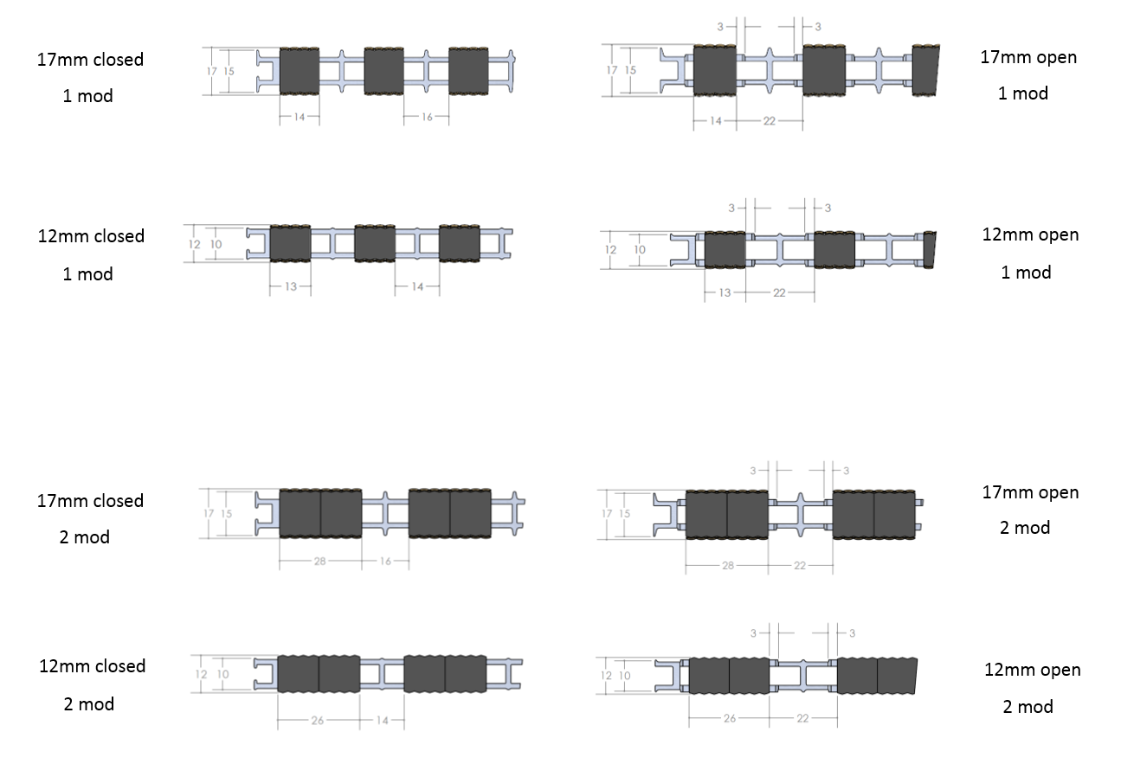

Bamboo:
