To complete the clause, select the appropriate wording from below. Highlighted text can be ‘dragged and dropped’ to save typing.

N10 GENERAL FIXTURES/ FURNISHINGS/ EQUIPMENT
300 ENTRANCE MATTING:

Nuway Grid is a single sided entrance system ideal for entrance areas subject to high levels of pedestrian traffic and where soiling has a high moisture or dust content. Every grid mat features a 100% recycled aluminium interlocking carrier section for durability with infill strips joined together by rubber double connecting strips on the underside to dampen sound and vibration.
Nuway Grid is available in 12mm and 17mm thickness.
A choice of 13 textile infills is available for interior use, with fluted rubber or Ultragrip safety rubber inserts for interior and exterior use.
Ultragrip rubber inserts have been tested using the Pendulum (the HSE recommended test method) in accordance with BS7976-2 and the UK Slip Resistance Group Guidelines and offer a low slip risk in wet and dry conditions.
Plain rubber fill-in profiles are available if required.
Consult with Forbo technical literature for further details.

300 ENTRANCE MATTING:

Manufacturer: Forbo Flooring UK Ltd, P O Box 1, Kirkcaldy Fife, KY1 2SB.
Tel: 01773 740 688 Fax: 01773 740 640
Email: info.flooring.uk@forbo.com. Web: www.forbo-flooring.co.uk

Product reference: Nuway Grid

Type: Single Module

Infill material and colour: Select from the following options:

Fluted Rubber – Black (for interior and exterior use)
Ultragrip safety rubber – black (for sure footing in multi-directional entrances, interior and exterior use)
Burford – black ribbed needlefelt for interior use only.
Coral Classic – 4701 anthracite/4730 raven black/4727 navy blue/4764 Taupe/4744 espresso/ 4750 Warm Black – for interior use only
Coral Brush Pure – 5710 asphalt grey, 5714 shark grey, 5721 hurricane grey, 5724 chocolate brown,. 5727 stratos blue, 5730 vulcan black – for interior use only

Thickness: 12mm / 17mm [Select required option]

Size: As drawing ref.

Matwell Frame: Select from the following options:
Existing
Recessed Aluminium AMF253/AMF346/AMF506
Ramped Aluminium: 12mm ARF 50 / 17mm ARF 70

Installation: Forbo Flooring recommends that Nuway Entrance systems are installed by a member of the FESSI (Forbo Entrance Systems Specialist Installer) network, details of which can found at the following link www.forbo-flooring.co.uk/FESSI

Construction options (all dimensions are approximate):

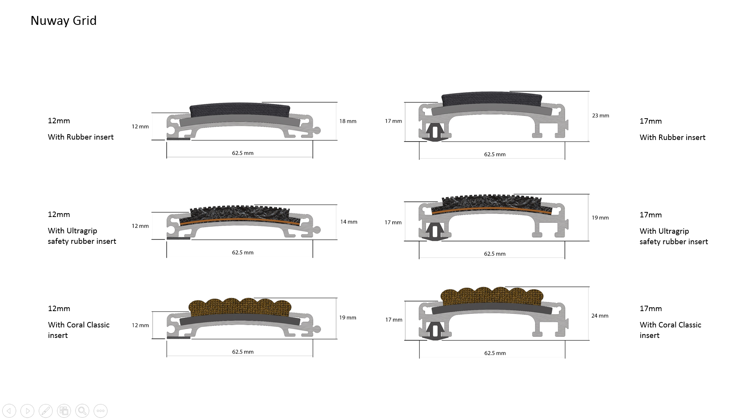

Rubber fill-in profiles ensure a neat matwell finish and facilitate cutting on site:

