Installation Guidance Note: Coral Entrance Flooring System Products

General

Sub-floor Preparation
The appearance, performance and durability of the installed floorcovering will be determined to a large extent by the quality of the prepared subfloor and the conditions in which they are laid.

The installation of Coral sheet, tile and plank products should be carried out in accordance with BS5325:2021 Code of practice for the installation of textile floor coverings. Areas to receive flooring should be clean, free from other trades, fully enclosed and weather tight. Subfloors should be clean and free of contaminants, smooth, sound and permanently dry.

Particular attention should be paid to the following:

- Problems associated with plasticizer migration from PVC materials can lead to dimensional instability in carpet tiles. All subfloors of this type must be removed before installation.

- It is impossible to ensure that wood block floors are not loose or contain latent defects through aging. It is therefore strongly recommended that these are removed and that the subfloor is correctly prepared and, if necessary, a surface damp proof membrane or an asphalt screed applied before installation of Coral tiles/planks.

- Raised access flooring panels tend to settle shortly after installation and this should be considered when assessing the appearance of the tile/plank installation fitted onto such flooring systems. Ridges between uneven raised access floor panels will telegraph through to the finished tile installation. Uneven or loose floor panels should be levelled or re-fixed before installing Coral tiles/planks. For Coral Sheet products, raised access floors should be overlaid with 5.5mm nominal plywood such as Hanson SP101 or products of equal specification.

The open time of the adhesive will depend on site conditions and porosity of the base. It is best practice to conduct an adhesive bond test before starting the installation. Bond testing will assist in identifying both the working characteristics of the adhesive (waiting and working time) for the site conditions, and also any potential bonding problems.

Always conduct moisture tests on all substrates. All ground-based level floors should have an effective moisture barrier.

Areas to receive flooring shall be adequately lit to allow for proper inspection of the substrate, installation and for final inspection.

It is essential that the laying area is at a steady temperature of 18 to 27oC for 48 hours prior to, during, and for 24 hours after installation.

Prior to installation, Coral tiles/sheet must be allowed to acclimatise in opened boxes for at least 24 hours in the above conditions. Rolls and cuts of Coral sheet products should be stored horizontally and allowed to acclimatise for at least 24 hours prior to installation. This is particularly important if the tiles/planks or sheet have been stored or delivered in conditions of extreme temperature and/or humidity. Where the floorcoverings have been stored or transported

immediately prior to delivery in temperatures below 10oC, the acclimatisation period should be extended to 48 hours.

Ensure that all recommendations for substrate and jobsite conditions are met prior to beginning the installation. Beginning the installation is an implied acceptance of site conditions by the parties involved and liability for any failure directly related to inadequate site conditions becomes the responsibility of the installer and/or flooring contractor.

When ordering sheet or tiles/planks, each floor area (plus any spares material) must be specified from the same batch. The batch number is clearly marked on the packaging and on the reverse side of rolls and tiles and must be checked before commencement of installation.

Rolls and tiles should be checked to ensure that the correct, colour, batch number and quantity have been received and are in good condition. No claim will be accepted for incorrect colour, pattern or obvious damage if the product has been fitted.

Any carpet tile can be susceptible to a certain amount of pile distortion when they are taken out of their boxes. This may result in visual differences in appearance between tiles/plankls during, and immediately following, installation.

After fitting and assuming normal prevailing conditions (under dynamic foot movement) this visual differential will diminish as the pile recovers to its natural position. Recovery will normally take place soon after installation. However, in some cases it can take up to six weeks for the pile to fully condition and develop a uniform visual appearance. Pile distortion is not a manufacturing defect,

Underfloor Heating
Coral Textile entrance systems are suitable for use with underfloor heating systems (Tog Values 1 to 1.5). When used with underfloor heating systems the temperature at the surface of the subfloor must not exceed 270 C.

A separate guidance note: “Installation of Forbo Floor Cov erings on Underfloor Heati ng Systems” provides more information on the conditions for installation in such circumstances.

Installation – sheet products

Coral sheet products should always be fully adhered.

The recommended adhesive for use with Coral is Eurocol 640 Eurostar Special (EC1 – low VOC)

Use a 1.5mm x 5mm V notched trowel to apply the adhesive.
Note: Trowels will wear during use, check the trowel both before and during use to ensure that the proper, specified trowel notch is used and maintained.

Note: the adhesive must be spread evenly over the entire floor area with particular attention to edges – this will ensure that the sheet is fully bonded at the perimeters.

Coral sheet products should be back rolled to relax the material before installing.

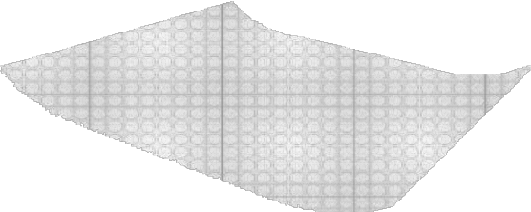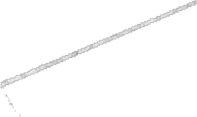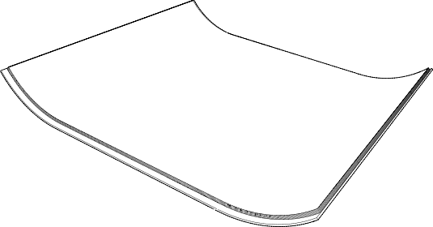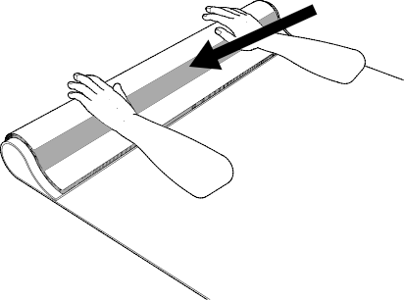

Place the material into wet adhesive, after the appropriate waiting time, and roll or press afterwards with a 68kg roller or carpet glider, rolling or pressing in all directions to ensure a firm bond. It is important to only spread sufficient adhesive that can be covered within the open time of the adhesive.

Areas that cannot be rolled with the large roller e.g. abutments such as door frames or skirting boards should be rolled with a hand roller or pressed into the adhesive with a rubbing hammer.

Always clean away excess adhesive with a damp cloth before it dries.

If alternative adhesives are to be used consult with the supplier for usage information, guidance and warranty.

There is an arrow indicating pile direction on the reverse of every backed sheet product. Install sheets with arrows running in the same direction.

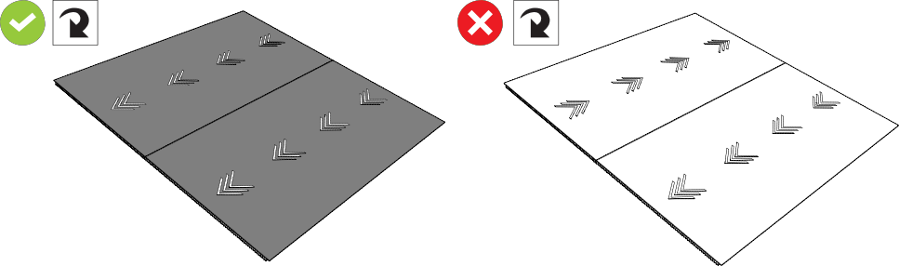

For all Coral textile products (except Coral duo) with an Everfort vinyl backing, trim with a straightedge and knife from the back of the sheet. Remove the 2.5cm edge border plus an additional 1cm to provide a suitable edge for butt jointing.

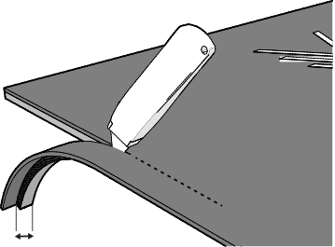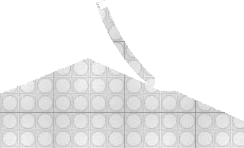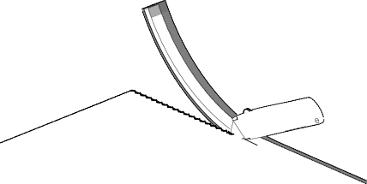
10

For Coral duo (Everfort vinyl backing) multiple width application, trim from the top with a straight edge and knife. Remove the 2.5cm edge border from all edges and any further material as necessary to maintain a continuous rib design between sheets.

Note: The direction of manufacture of Coral duo is not the traffic direction – ensure the ribs are running at right angles to the walking direction.

Note: Seams in the main footfall area e.g. in the centre of a doorway should be avoided.

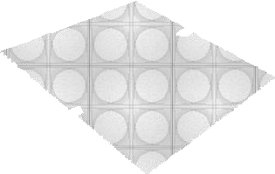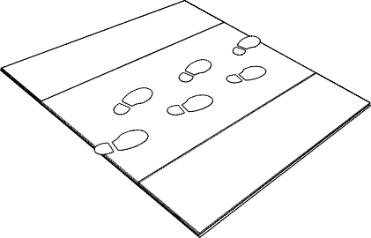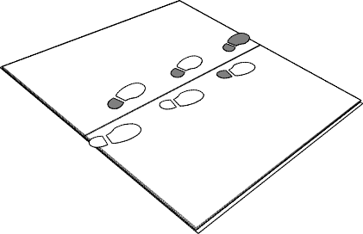

Installation – Coral tiles and planks

Coral tiles and planks must be adhered using a high grab, all-over tackifier adhesive system; Forbo Eurocol 542 Eurofix Tack Plus is recommended.

The tackifier adhesive must be spread evenly over the entire floor area with particular attention to edges – this will ensure any perimeter tile cuts are fully bonded. Failure to fully bond all full tiles and tile cuts may result in individual tiles/planks shifting and lifting

Where perimeter tiles/planks are not constrained by fixtures e.g. walls, edge strips etc., it is recommended that such tiles/planks are adhered using a permanent adhesive; Forbo Eurocol 640 Eurostar Special is recommended.

Adhesives must be applied according to the manufacturer’s instructions and it is essential that tackifier adhesives are allowed to dry to a clear, tacky finish before laying the carpet tile. Failure to do so could result in a permanent non-release bond.

The arrow marks on the reverse of every tile indicate the direction of pile lay. The preference of the specifier as to
“broadloom”, “tessellated” or other visual effects must be confirmed before tiles are installed.

When laying tiles in a monolithic format follow the direction of the arrows, which should, where possible, point towards the main light source.

Note: the term ‘broadloom’ is often used as an alternative description of monolithic. Whichever term is used, it refers to the installation direction of the carpet tiles. It does not mean that the installation will be viewed as seamless. Tile edges are most visible in new installations. The quality of Coral carpet tiles’ construction will help to reduce the visibility of tile edges over time (with traffic and regular vacuuming) however, tile edges may remain visible during the life of the product in non or low trafficked areas.

Pile trapping – Ensure that each tile/plank butts up to its neighbour as tightly as possible without causing it to peak or
“dome” off the subfloor. It is essential that no pile material becomes entrapped between tiles. Any trapped pile will distort the overall tile adhesion bond which may affect the long-term tile bonding as well as negatively affecting the tile edge aesthetic.

The location of the starting point of an installation is usually determined by the fitter to maximize the yield.
This may be anywhere in the room but would normally be located as near to the true centre as possible. Small cuts in either the field or perimeter should be avoided.

Having established the starting point for the installation, making some check measurements or dry laying a few rows of tiles and planks will help to identify any potential problems or necessary adjustments to avoid small perimeter cuts.

Note: Coral Interior (tiles and planks) is specially developed to install it in random order to give it is special design. Pile direction is not an issue in this kind of installation but as the design of each tile or plank can be different it is advisable to check the lay out before starting the installation.

It is important when fitting Coral Interior tiles and planks to ensure that they are each carefully placed against the adjacent tiles – do not slide the tiles and planks into place.

Fitting to stair treads and risers
All Coral sheet, tile and plank products are recommended for use on stairs. Appropriate stair nosings must be used for every tread. Coral sheet must be bonded securely to the stair tread using a permanent bond adhesive (Forbo Eurocol 640 Eurostar Special). Fitted to risers the sheet, tile and planks should be permanently bonded using a suitable contact adhesive.
Note: It important that sheet, tile or planks are fitted to treads with the pile direction (arrows) facing inwards towards the riser and fitted to risers with the pile direction (arrows) facing downwards towards the tread.

Note: As Coral products are available in a variety of sheet backing and tile/plank options, the product is tufted and held as unbacked stock before manufacture to the selected product type. The tufting production number is printed on the back of each tile/plank whilst the tile production batch number is printed on the box. Please ensure the same box batch number is used in each location as mixed box batch numbers may result in shade variations.

Installation – Coral loose lay mats

Loose lay Coral mats may be used on smooth resilient flooring surfaces either as a temporary solution (in accordance with HSE guidance) or in areas where a fitted Coral zone is impractical. In any location or use, it is important to check
that the Coral PVC backed mat is compatible with the existing flooring. For example, vinyl flooring may permanently discolour, due to the effect known as plasticiser migration between the two PVC surfaces.

In some instances, with compatible very smooth floors, some slippage of the mat may still occur. If this is experienced, the mat should be secured using PMR (Plasticiser Migration Resistant) double sided tape.

Please note:
  - The use of Coral mats on top of any type of textile flooring is not recommended due to the high likelihood of the mat moving on the textile products surface pile with the resultant potential to cause a trip hazard.
  - Always ensure that the Coral mat is flat during use (and storage) to avoid edges curl.

On completion of the installation

First impressions may have more impact on the client than hours of skilled fitting.

The completed installation should be cleared of scrap material and debris, the floor vacuumed and any traces of adhesive residues removed from the floor and skirtings.

Note: Upright vacuum cleaners with a mechanically powered brush should be used on all Coral products.

If the floor covering is to be protected from other trades or site traffic prior to project completion, a protection product should be chosen that is appropriate for the type and level of traffic likely to be experienced.

Note: some protective sheet products with a tacky film in contact with textile floor coverings can leave an adhesive residue when removed. This can be difficult to remove and attract dirt when the floor covering is put into use. The potential for this effect should be checked with the protection product manufacturer before use and advice on suitability confirmed. Forbo will not accept any claims for soiling problems associated with the use of such products.

If the optimum performance of any new floor covering is to be achieved, it is important that the correct cleaning and maintenance procedures are used from day one. Cleaning and maintenance guides for all Forbo Flooring Coral ranges are available for download at: www.forbo-flooring.co.uk/downloads

Cleaning and maintenance guides should be passed onto the main contractor, client or end user as appropriate on completion of the installation, and before any hand over clean is started.

Any questions please contact us:
Forbo Flooring UK Ltd
Tel: 0800 121 4780
Samples: 0800 731 2369
Info.flooring.uk@forbo.com www.forbo-flooring.co.uk

Additional Reference documents and Information:
- BS5325:2021
- The CFA Guide to Contract Flooring (Tel: 01159 411126)

