Installation Guidance Note: General guidance – Eternal

General Advice

The appearance, performance and durability of the installed floorcovering will be determined to a large extent by the quality of the prepared subfloor and the conditions in which they are laid.

Forbo floor coverings are manufactured for internal use only. The product performance is not guaranteed for use in external environments.

Subfloor preparation should be carried out in accordance with BS8203:2017 Code of practice for the installation of resilient floor coverings. Areas to receive flooring should be clean, free from other trades, fully enclosed and weather tight. Subfloors should be clean and free of contaminants, smooth, sound and permanently dry.

Always conduct moisture tests on all substrates. All ground-based level floors should have an effective moisture barrier.

Areas to receive flooring shall be adequately lit to allow for proper inspection of the substrate, installation and for final inspection.

It is essential that the laying area is at a steady temperature of 18 to 27oC for 48 hours prior to, during, and for 24 hours after installation. The material and adhesive should be conditioned in the same environment for at least 24 hours prior to the installation. Where the floorcoverings have been stored or transported immediately prior to delivery in temperatures below 10oC the acclimatisation period should be extended to 48 hours.

Prior to installation rolls should be checked to ensure that the correct colour, batch number and quantity have been received and that the material is in good condition. No claim will be accepted for incorrect colour, pattern or obvious damage if the material has been fitted.

Use material from the same batch/dye lot and install in roll number sequence. The use of different production batches will always result in visible shade differences. The batch number is clearly marked on the material packaging and must be checked before commencement of installation.

Install one length of sheet at a time, making sure to place the material into wet adhesive and roll afterwards with a 68kg roller, rolling in all directions to ensure a firm bond. It is important to only spread sufficient adhesive that can be covered within the open time of the adhesive.

Note: the adhesive must be spread evenly over the entire floor area with particular attention to edges – this will ensure that the sheet is fully bonded at the perimeters.

Areas that cannot be rolled with the large roller e.g. abutments such as door frames or skirting boards should be rolled with a hand roller or pressed into the adhesive with a rubbing hammer.

Always clean away excess adhesive with a damp cloth before it is allowed to dry.

As with all newly installed floor coverings Eternal should be protected from heavy traffic for 48 hours or, if the floor is to be subjected to high point load or wheeled traffic, for five days. The floor must not be washed for 48 hours after installation.

Eternal can be used in conjunction with under-floor heating systems. A separate guidance note “Installation of
Forbo Floor C ov erings on Underfloor Heati ng Systems” provides more information on the conditions for installation in such circumstances.

Direction of laying
The following installation advice should be followed in relation to direction of sheet laying.

The installation direction for each design is indicated on the product brochure, packaging and the back of the sheet. The following general guidance applies, but it is important to check the required installation method for each sheet when planning the installation.

Reverse lay designs: - Material and Colour ranges

Reverse installation of alternate sheet lengths is required.

Directional designs: - Wood range* and Colour Rainbow options (3)**

Sheet lengths should be installed in the same direction.

Notes:
*see additional guidance for seaming wood designs later in this document.
**may not pattern match across the seam

Adhesive Recommendations and application

For standard installations Eurocol 540 Eurosafe Special adhesive is recommended, however, if a low emission EC1
adhesive is required, Eurocol ‘640 Eurostar Special’ should be used.

Use a 1.5mm x 5mm V notched trowel to apply the adhesive.

Note: Trowels will wear during use, check the trowel both before and during use to ensure that the proper, specified trowel notch is used and maintained.

The open time of the adhesive will depend on site conditions and porosity of the base. It is best practice to conduct an adhesive bond test before starting the installation. Bond testing will assist in identifying both the working characteristics of the adhesive (waiting and working time) for the site conditions, and also any potential bonding problems.

If alternative adhesives are to be used consult with the supplier for usage information, guidance and warranty.

Installation
Always check the recommend direction of laying before cutting sheet length (see “Direction of laying above).

Cut the sheet material to the required lengths and then back roll each cut length before cutting to fit in order to release any roll tension from the winding of the sheet (see below).

Back rolling
Sheet vinyl products are tightly rolled in the factory. The tension caused by this process will mean that the goods may shrink a little in the length when unrolled. It is recommended to reduce the effect of shrinkage by re-rolling the cut lengths of sheet back on themselves and allowing to stand in this state for 15 minutes prior to unrolling again and commencing fitting.

It is recommended that the roll lengths are rolled out and laid out flat in the installation area to acclimatise for 24 hours at a minimum temperature of 18o C prior to commencing fitting the sheet.

Cutting and fitting
Each sheet be should be scribed to fit and the factory edge removed before cutting the seam. Seams should be overlapped and under-scribed or cut with a seam cutter to form a close butt joint. See below.

Note: Wood designs requires a slightly different approach when forming seams. Further guidance is given in this document and in separate guidance note “Seaming Eternal and Surestep Wood” provides more information for seams in these wood designs.

Scribe the long side of the sheet to the wall first. Place the sheet back against the wall. With the sheet fitted correctly in position along the length, and the ends riding up the end walls, trim the factory edge on the opposite side of the sheet using a seam cutter or by striking a chalk line and cutting through the sheet following this line with a straight and utility knife.

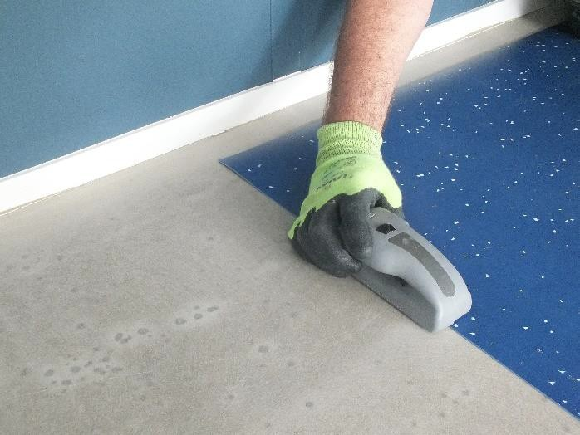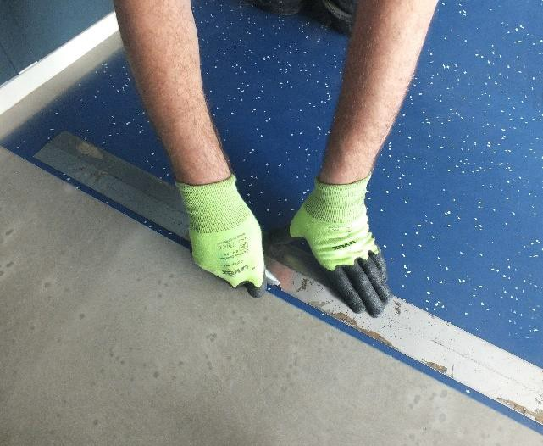

Trace the line of the trimmed edge onto the subfloor with a pencil. This line acts as a guide line.

Place a ruler or straight edge, at right angles to the sheet. Across the edge of the sheet draw a cross check on both material and subfloor (Fig. 1). Fold one end of the sheet back on itself, pull the other end clear by about 25mm from the wall (fig.2). Position the sheet to lie flat on the floor, with the edge true to the guide line (B). Set the bar scriber at the distance that the cross check has opened up (fig. 3).

Tip: As an alternative to pulling the sheet length back, the roll core may be placed under the sheet to create the necessary gap between the sheet end and the wall. This will also help to prevent creasing the sheet during when pulled back.

Keep the scriber parallel to the guide line and scribe the end of the sheet (fig.4). Cut the material along the scribe line. Check fit to the wall, with the aid of the cross checks and the guide line.

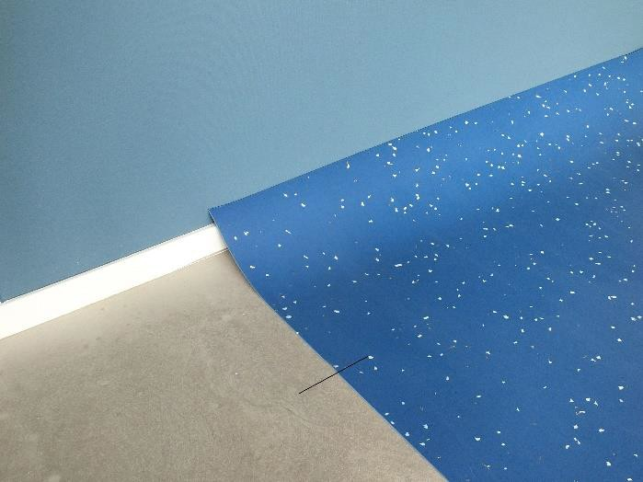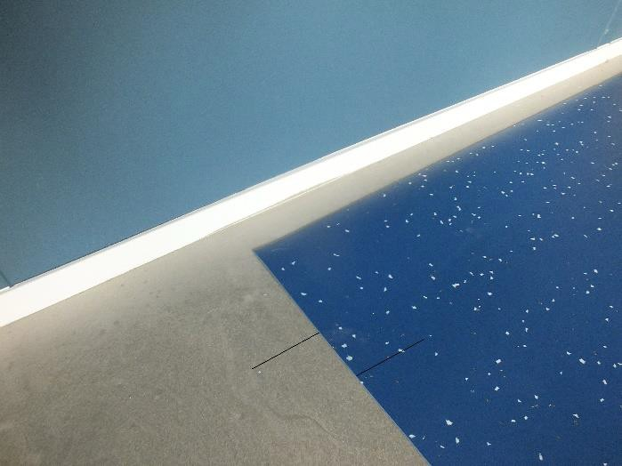
Fig. 1 Fig. 2

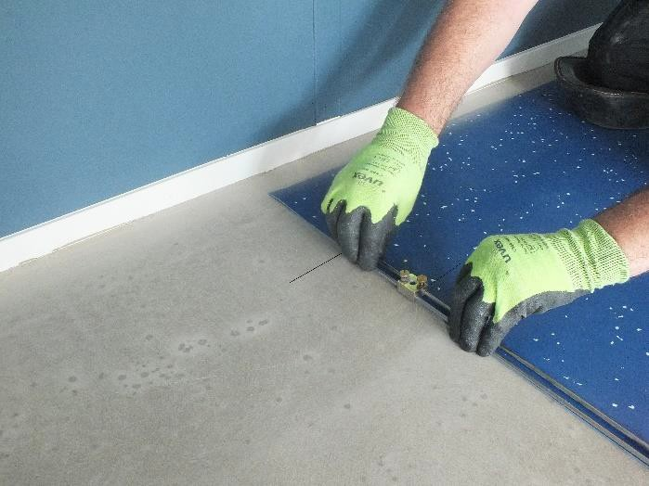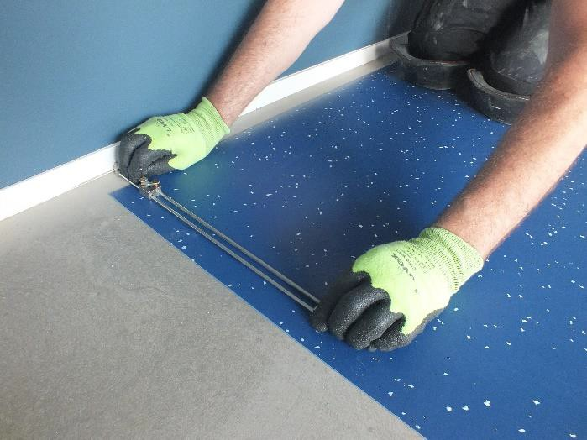
Fig. 3 Fig.4

Scribe and cut the other end of the sheet using the same method.

Fitting long lengths
During the manufacture of sheet vinyls the material is stretched slightly in the length. Often the first opportunity it has to relax fully is when it is unrolled, scribed and folded back for the spreading of the adhesive. If the length being fitted is a long one, this relaxation can be significant enough for slight shrinkage to occur, leaving the fitted end a little short of the wall once folded down again into the adhesive.

To avoid this, scribe and fit one end of the sheet and then stick all but the last 11/2-2 metres at the other end before scribing and fitting this end. Any relaxation during the folding back of such a short length will not be significant. The full length must be stuck and rolled while the adhesive is still active.

Lay the next sheet alongside the first fitted sheet with the sheet ends lapping up the wall and the edge of the sheet overlapping the previously fitted sheet by approximately 2cm. Trim the factory edge of the opposite side of this sheet as above and trace the line of the trimmed edge onto the subfloor with a pencil.

Scribe and cut each end of this length as for the first sheet.

Cut the seam using a seam cutter or under scriber to form a close butted seam (see below).

Repeat this process for each subsequent sheet length. The final length which abuts the opposite wall should be cut and fitted using the method described for the first length.

Note: factory edges should always be trimmed to form a true edge for seaming

Seam cutting
Cut the seam using a seam cutter or under scriber to form a close butted seam (see below).

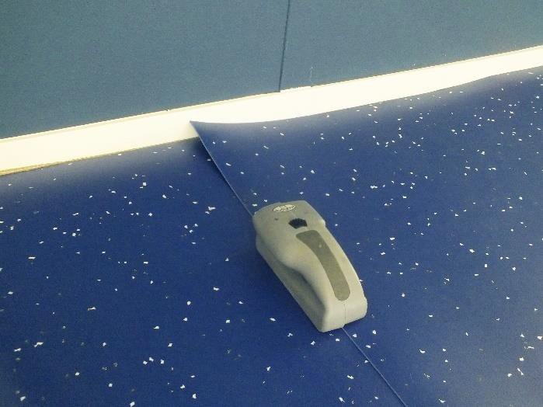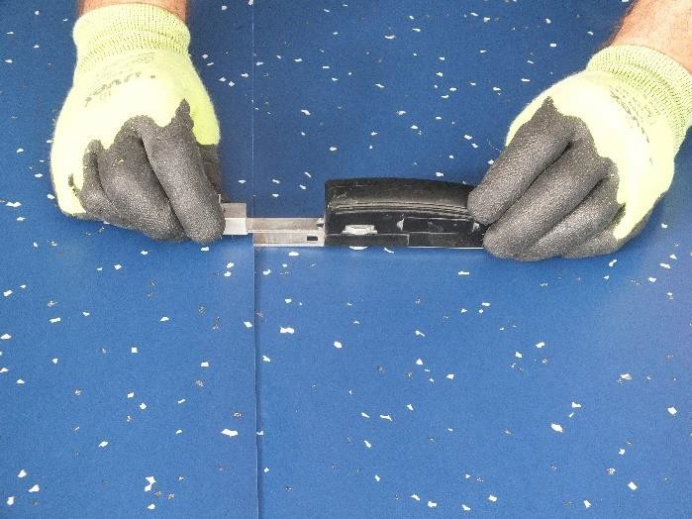

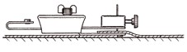

Cutting seams for Eternal Wood designs
Eternal Wood ranges are manufactured with a selvedge on both edges of the roll. Adoption of the following advice will assist in achieving the optimum seam visual and minimise wastage.

There is usually a narrow selvedge on one side of the sheet and a wide selvedge on the other – this is intentional to allow for edge trimming (fig.1). The narrow selvedge should be trimmed to within 2 to 3mm of the print line or along the print line of the plank depending on the installer’s preference for the location of the welded seam (fig.2). The wider selvedge on the opposite side of the sheet should have a minimal trim (fig.3).

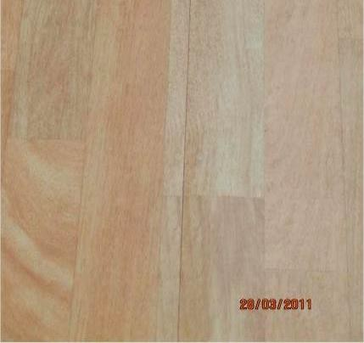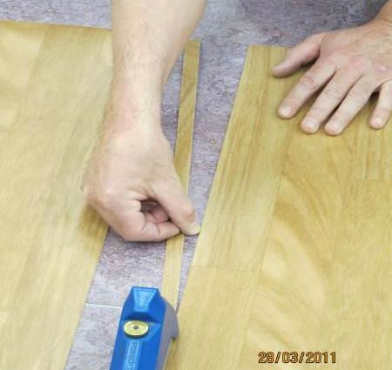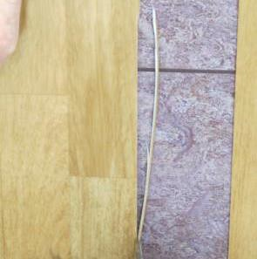
Fig.1 Fig.2 Fig.3

Note: if the print line is also visible on the wider selvedge side of the sheet trim the sheet along the print line.

After trimming, the plank that contains the welded seam may be slightly narrower than the main body. This will be lost in the overall design of the finished floor.

Whether the welded seam is cut along the print line or adjacent to it, pattern matching of the plank design on side seams is not neccessary.

Cross Seams - Lay out the next roll aligning the plank design as shown below. Adjust the depth of the ovelap to form a cross seam with continuity of pattern match of the plank design across the width of the sheet.

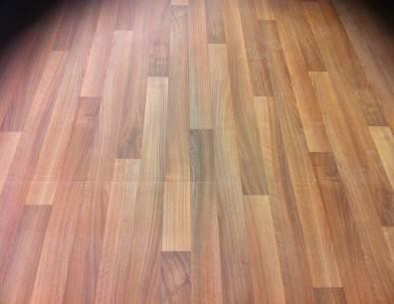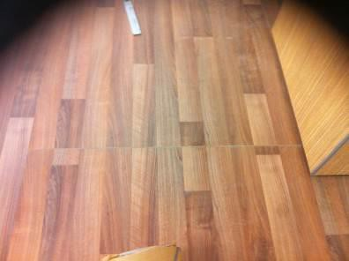

Correct Incorrect

Unless agreed otherwise and where the setting out allows cross seams should be staggered for best visual effect

Adhering the sheet

Following these recommendations will give the installer the best opportunity to manage the open and working time of the adhesive and ensure that the flooring material is placed into wet adhesive.

Pull back the sheet length to approximately half way.

Placing the roll core on the sheet at the point of the fold to support the material whilst folded back will help to prevent creasing the sheet whilst spreading the adhesive.

Spread the adhesive using the appropriate notched trowel ensuring that the correct trowel notch in maintained throughout the installation – see adhesive guidance above.

Lay the sheet into the adhesive after the appropriate waiting time and rub the sheet with a rubbing board or glider from the centre outwards to remove any trapped air between the sheet and the adhesive. Roll with a 68kg roller, rolling in all directions to ensure a firm bond.

Note: Ensure that the sheet does not move during this process and that the close butt seams are maintained when placing the vinyl sheet into the adhesive.

Coved Skirtings
Eternal can be used in conjunction with standard PVC set in coved skirtings or site formed using standard techniques with a 20mm or 38mm cove former.

If site formed coving is being used for Eternal Wood designs, the optimum visual effect will be achieved by laying with a border cove either in the same design or with a contrasting uni colour /all over design.

Seam grooving

Seams should be grooved to a depth of approximatley 2/3rds of the material thickness. A ‘P’ Type groover (Fig.11) is recommended for manual grooving of seams, however, automatic or power groovers may be more productive on larger installations.

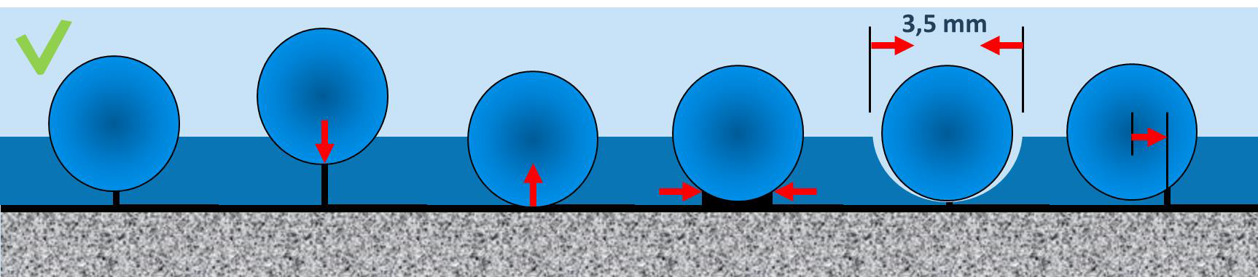

Welding
Switch on the hot air gun and allow 5 to 7 minutes for it to reach the selected temperature. Eternal should be welded at a temperature of approximately 400° C. (see weld gun manual for setting details). Fit the welding nozzle before switching on the hot air gun.

If the gun is resting on the floor ensure that the nozzle is not directed at the floor or anywhere dangerous.

Weld guns will vary, so it is always advisable to practice weld techniques first on a piece of waste material to match the correct air gun temperature with welding speed. Eternal should be welded with a 5mm Speedweld nozzle.

Make sure the groove is thoroughly clean before beginning to heat weld. Make sure that all electrical cables are laid out without tangles and that there are no obstructions along the seam to be welded.

Cut the welding cable to a consistent and generous length or unwind sufficient weld rod from the reel and put the reel in a position where you are working towards it. Have the power cable ahead of you if possible.

Start at a wall. Thread the cable through and weld moving backwards, away from the wall, maintaining a slight downward pressure so that the weld nozzle will force the weld cable into the groove. Do not let the cable melt in the nozzle.

A good weld is obtained by the correct combination of temperature, speed and downward pressure. The weld cable should be allowed to melt enough so that the melted rod reaches the bottom of the groove.

Trimming
While the cable is still warm trim off most of the top half of the cable down to approximately 0.5mm using a Mozart knife or sharp spatula and slide which fits over the cable. This enables the cable to cool more quickly and enables a quick first cut to be made without risk of gouging the material.

The welding cable will dish slightly (concave downwards) as it cools. Wait until the material is completely cool before trimming flush with the surface of the sheet with a Mozart knife 0r sharp spatula angled slightly across the line of cut.

Note: To avoid unintended damage to the floor covering Forbo recommends to use the Mozart knife for trimming the weld cable. If a sharp spatula is being used special care should be given to avoid damaging the sides of the seams.

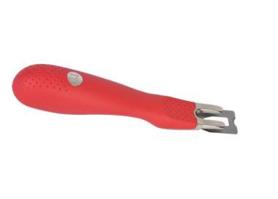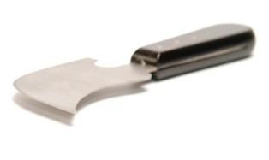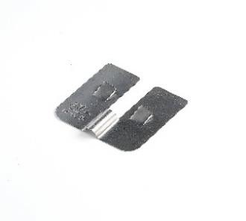
Motzart knife Spatula Slide

Note: Making the final trim while the welding rod and material is still warm can result in the weld cable dishing of the weld cable. This may result in subsequent seam soiling problems or cause permanent damage to the surface of the flooring.

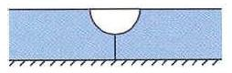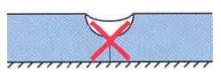

Joining up a weld
To join a weld in the middle of a seam trim off the loose ends and chamfer down the section to be overlapped with a hand groover. Ensure hot air gets into the groove and heats the cable. As the gun travels over the un- welded section apply pressure and carry the weld on over the section to be joined. Allow to cool and trim as normal.

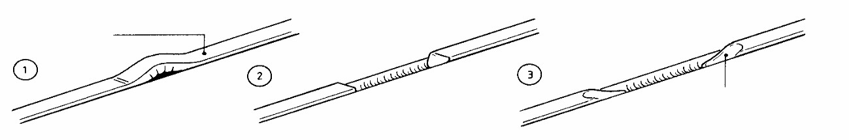

Perimeter sealing

If the purpose of specifying welded seams is to prevent the risk of moisture getting under the floorcovering then logically the specification must ensure that perimeters are also sealed, together with any areas where pipes, etc. come up through the floorcovering. This is usually done with a silicone sealer but in special areas, such as prisons, a hard-setting epoxy may be used.

On completion of the installation

First impressions may have more impact on the client than hours of skilled fitting.

The completed installation should be cleared of scrap material and debris, the floor swept or vacuumed and any traces of adhesive residues removed from the floor and skirtings.

If the floor covering is to be protected from other trades or site traffic prior to project completion, a protection product should be chosen that is appropriate for the type and level of traffic likely to be experienced and the potential for impact, scratching or indentation damage.

In many cases it is customary for the initial floor preparation to be left, or subcontracted, to a professional cleaning and maintenance contractor who will have the staff and equipment to do the job thoroughly.

If the optimum performance of any new floor covering is to be achieved, it is important that the correct cleaning and maintenance procedures are used from day one. Cleaning and maintenance guides for all Forbo Flooring sheet vinyl products are available for download at: www.forbo-flooring.co.uk/vinyldownloads

Cleaning and maintenance guides should be passed onto the main contractor, client or end user as appropriate on completion of the installation, and before any hand over clean is started.

If in any doubt contact us:

Forbo Flooring UK Ltd Tel: 0800 0282 162
Fax: 01772 646912
Samples: 0800 731 2369 Info.flooring.uk@forbo.com www.forbo-flooring.co.uk

Additional Reference documents/Information

Forbo Floor Coverings Installation Guide. (Tel: 0800 731 2369) BS8203:2017
The CFA Guide to Contract Flooring (Tel: 01159 411126)

