Forbo Flooring Systems has relaunched its popular Tessera Create Space 1 collection with a newly updated palette of 18 colour options, including 11 entirely new additions. The range of commercial carpet tiles also boasts excellent environmental credentials such as a leading 75% recycled content by weight, including ECONYL® nylon, which is produced entirely from regenerated post-consumer and post-industrial waste.

The low-level loop pile of the Create Space 1 range is ideal for any commercial interior including high traffic applications. It has an impact sound reduction value of 25 decibels (dB) for minimal noise transmission, Class 33 durability and is supplied with a 10-year guarantee.

The new trend-led colour palette has been created to provide choice and flexibility for commercial interiors. Colours added to the range include the rich tones of Jadeite, Lazulite, Garnet, Kyanite and Citrine. These contrast with the newly added Pearl, Agate and Jasper colours as well as the existing tones in the Create Space 1 collection such as Ebonite, Feldspar, Tawny and Nickel.

The versatile collection can be used in single colourway installations or, by combining shades, it can be used to create feature areas, aid wayfinding or allow you to design bespoke schemes. It can also be laid in monolithic, quarter turn or tessellated patterns.
What’s more, Create Space 1 can be combined easily with Forbo’s Allura Flex LVT planks using the same tackifier and without the need for transition strips, additional profiles or build-up of the sub-floor, allowing integrated flooring schemes to be designed with ease.

Create Space 1 has also been designed to help reduce the impact on the environment. The ECONYL® regenerated nylon that the entire Create Space 1 range is manufactured from is sourced from waste such as fishing nets, fabric scraps and carpet. Through an innovative regeneration and purification process the infinitely recyclable nylon is returned to its original quality, ready to be reused. This reduces the global warming impact of the nylon by up to 90% compared with producing it from oil.

Donna Hannaway, Head of Marketing at Forbo Flooring Systems commented: “Create Space 1 provides designers with an ideal option for demanding commercial environments, including workplaces and educational facilities. As well as the launch of a newly refreshed colour palette, which provides even greater choice and design possibilities, the collection now contains 75% recycled content by weight – the highest of any Tessera flooring product with Probac backing, and like many products in the Forbo portfolio, it is also manufactured using 100% renewable energy. As a result, Create Space 1 exceeds the SKA rating criteria for M12 (soft flooring) and achieves a BREEAM rating of A or A+ depending on the building type.

To find out more about the refreshed Tessera Create Space 1 collection visit www.forbo-flooring.co.uk/createspace1

-ENDS-

Image | Information
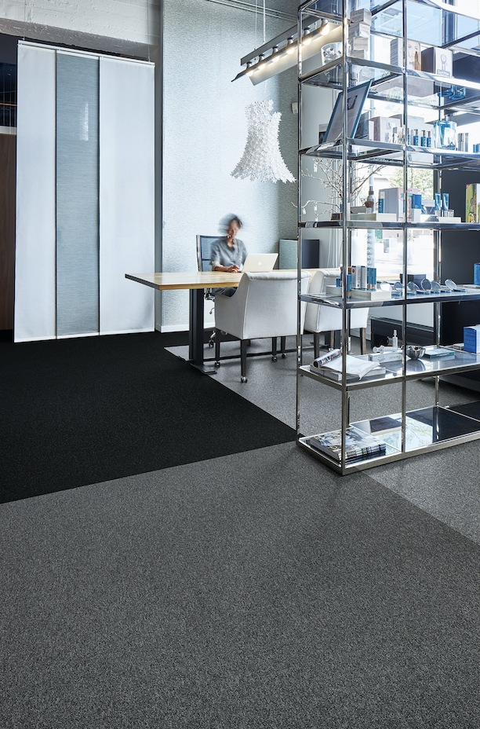 | Tessera Create Space 1 in Ebonite, Lithium and Nickel
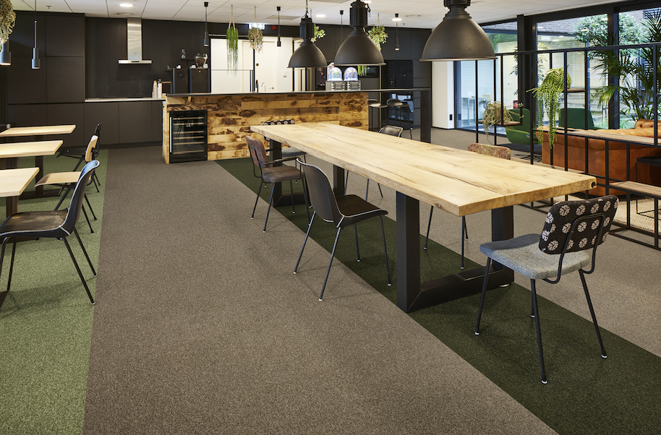 | Tessera Create Space 1 in Jadeite, Serpentine and Tawny
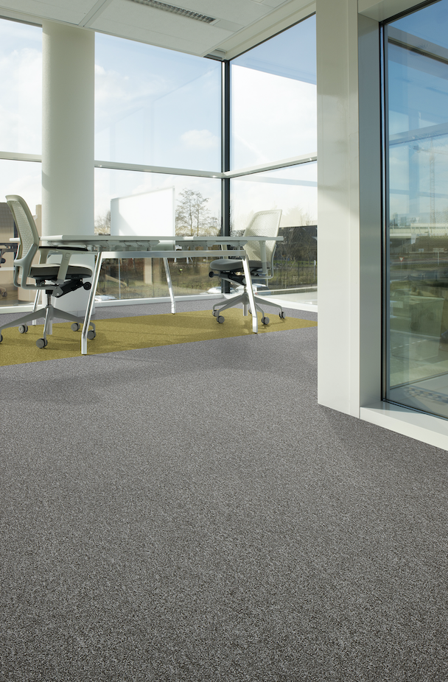 | Tessera Create Space 1 in Opal and Citrine

Increases to 80% for our Softbac version

